N+ NETWORK SECURITY

Section A: Scenario-Based Concept Application

- Explain the selection process for CPU, RAM, and storage specifications to ensure hardware compatibility and prevent performance bottlenecks for a startup team performing concurrent development and video conferencing tasks.
For a startup team doing software development and video conferencing at the same time, we need to select hardware that can handle multiple applications simultaneously.
I.CPU SELECTION
The CPU should have:
- Multiple cores and threads.
- Good clock speed.
- Compatibility with the motherboard socket and chipset.
- Support for the required RAM type.
A modern multi-core processor is preferred because development tools, browsers, IDEs, and video conferencing may run simultaneously.
II.RAM SELECTION
RAM is important because multiple applications use memory at the same time.
A suitable system should have:
- At least 16 GB RAM for comfortable multitasking.
- More RAM, such as 32 GB, if developers use virtual machines, containers, or other memory-intensive applications.
- RAM compatible with the motherboard.
III.STORAGE SLECTION
An SSD should be preferred over an HDD because SSDs provide faster
- Booting
- Application loading
- File access
- Compilation and development operations
An NVMe SSD can provide even higher performance than a SATA SSD.
IV.COMPATIBALITY
Before purchasing components, check:
- CPU socket ↔ motherboard
- RAM type and supported capacity ↔ motherboard
- SSD interface ↔ motherboard
- PSU capacity ↔ total system power requirements
- Explain how system resource allocation and hardware bottlenecks contribute to performance degradation after the deployment of resource-intensive background applications like antivirus software.
A computer has limited resources such as CPU, RAM, storage and network bandwidth.
When a resource-intensive antivirus program runs in the background, it uses some of these resources.
CPU BOTTLENECK
Antivirus software may continuously scan files and processes.
If the CPU is already heavily loaded, the additional antivirus workload can cause:
- Applications to become slow.
- Longer processing times.
- System responsiveness to decrease.
RAM BOTTLENECK
Antivirus software also requires RAM.
If available RAM becomes low, the operating system may use disk-based virtual memory/pagefile.
Because storage is slower than RAM, applications may become slower.
STORAGE BOTTLENECK
During a full antivirus scan, many files are read from storage.
If the storage device is already busy, file operations can become slower.
- Explain the systematic troubleshooting process for resolving peripheral hardware failures caused by driver incompatibility or operating system conflicts when a device functions inconsistently across different workstations.
If a printer, scanner, keyboard, USB device, etc. works on one computer but not another, the problem may be related to drivers, operating-system compatibility, ports, or configuration.
Step 1: Check the physical connection
- Check USB/network cable.
- Try another USB port.
- Check whether the device has power.
Step 2: Test the device on another workstation
If the device works on another computer, the device itself is probably working.
Step 3: Check Device Manager
In Windows:
Device Manager → Find the device
Look for:
- Warning symbols.
- Missing drivers.
- Disabled devices.
Step 4: Install the correct driver
Download the correct driver for:
- Device model.
- Operating system.
- System architecture, such as 64-bit.
Step 5: Remove incompatible drivers
Uninstall the problematic driver and install the correct version.
Step 6: Check OS compatibility
Some older devices may not have drivers for newer operating systems.
Step 7: Restart and test
Restart the computer and test the peripheral again.
Step 8: Check for conflicts
Check:
- Windows updates.
- Driver conflicts.
- Resource conflicts.
- Security software restrictions.
- Explain the role of Uninterruptible Power Supply (UPS) systems and surge protection in preventing file system corruption and ensuring data integrity during unexpected power fluctuations
A UPS (Uninterruptible Power Supply) provides temporary power to a computer when the main electricity supply fails.
UPS helps by:
- Providing backup power.
- Giving users time to save their work.
- Allowing the computer to shut down safely.
- Preventing sudden power loss.
Surge Protection
A surge protector protects equipment from sudden increases in electrical voltage.
Why is this important?
Suppose a computer is writing data to the disk when electricity suddenly goes off.
Power failure → incomplete write operation → possible file-system corruption
A UPS reduces this risk by keeping the computer powered temporarily.
Benefits:
- Protects hardware.
- Reduces data loss.
- Reduces risk of file-system corruption.
- Provides time for safe shutdown.
- Protects against some electrical disturbances.
Conclusion:
UPS = temporary backup power
Surge protector = protection from voltage spikes
Together they improve system and data protection.

Section B: Practical Application
TASK1: Physically Assemble a Workstation and Document the Component Installation Sequence.
Step 1: Prepare the workplace
- Shut down and unplug all equipment.
- Use an anti-static wrist strap if available.
- Keep screws and components organized.
Step 2: Install the CPU
- Open the CPU socket.
- Align the CPU correctly.
- Place it gently into the socket.
- Lock the socket mechanism.
Step 3: Apply thermal paste
Apply a small amount of thermal paste if the CPU cooler does not already have thermal paste applied.
Step 4: Install CPU cooler
- Place the cooler on the CPU.
- Secure it properly.
- Connect the CPU fan cable to the motherboard CPU_FAN header.
Step 5: Install RAM
- Open the RAM slot clips.
- Align the notch on the RAM module.
- Press it down until properly seated.
Step 6: Install motherboard
Place the motherboard inside the case and secure it with the correct screws.

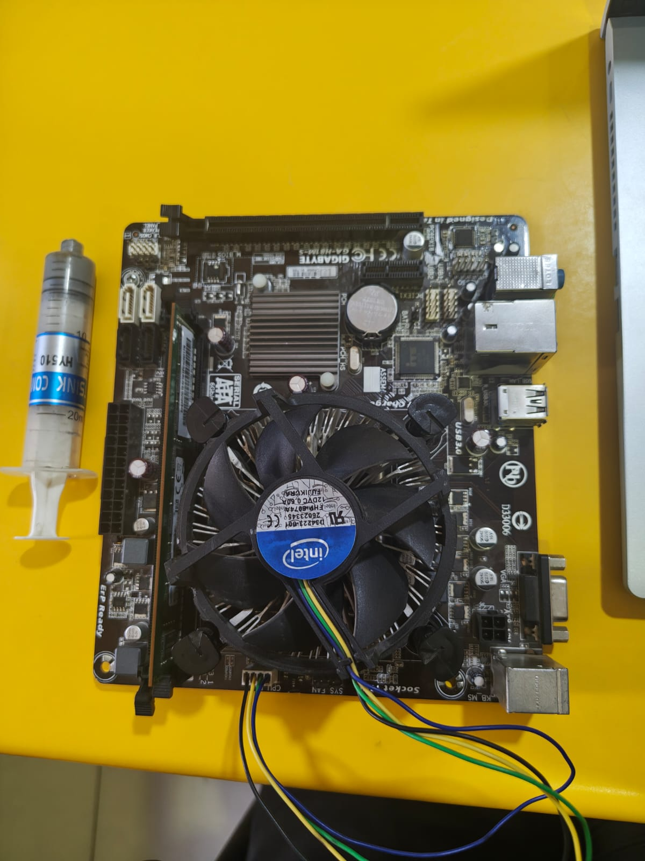
Step 7: Install storage
Install the:
- HDD, or
- SATA SSD, or
- M.2/NVMe SSD.
Step 8: Install PSU
Place the PSU in the case and secure it.
Step 9: Connect power cables
Connect the required:
- 24-pin motherboard power.
- CPU power cable.
- GPU power cable, if required.
- Storage power cables.
Step 10: Connect front-panel cables
Connect:
- Power switch.
- Reset switch.
- Power LED.
- HDD LED.
- USB.
- Audio.
Step 11: Install GPU
If required:
- Insert the graphics card into the appropriate PCIe slot.
- Secure it.
- Connect its power cable if required.
Step 12: Final inspection
Check that:
- RAM is properly installed.
- CPU cooler is connected.
- Power cables are connected.
- No loose screws are inside.
- Fans can rotate freely.
Step 13: Power on
Turn on the computer and check whether it successfully completes POST.
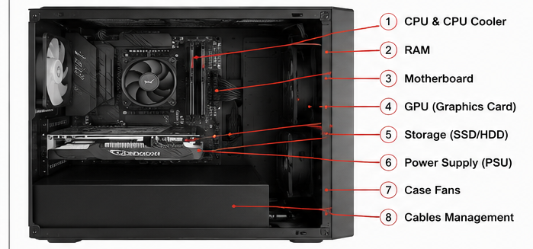

TASK2: Troubleshoot and Resolve a RAM Mismatch Error within BIOS/UEFI Settings.
PROBLEM:
The computer may show a RAM mismatch or memory-related error because of:
- Unsupported RAM.
- Incorrect RAM settings.
- Incorrectly installed RAM.
- Different RAM modules.
- Incorrect memory speed/timing.
- Faulty RAM.
Procedure:
Step 1: Turn off the computer
Disconnect the power.
Step 2: Check RAM installation
Remove and reinstall the RAM properly.
Step 3: Test one RAM module
If there are multiple modules, test them individually.
Step 4: Enter BIOS/UEFI
Turn on the computer and press the appropriate key, commonly:
Delete / F2 / F10 / Esc
depending on the motherboard.
Step 5: Check detected RAM
Look for the total memory shown by BIOS/UEFI.
Example:
Installed RAM = 16 GB
BIOS should normally detect approximately 16 GB.
Step 6: Check memory settings
Check:
- RAM frequency.
- Memory voltage.
- XMP/EXPO settings, if supported.
If an overclocked memory profile is causing instability, return the memory to default settings.
Step 7: Save settings
Save changes and restart.
Step 8: Test RAM
Use a memory-testing tool such as Windows Memory Diagnostic or MemTest86.

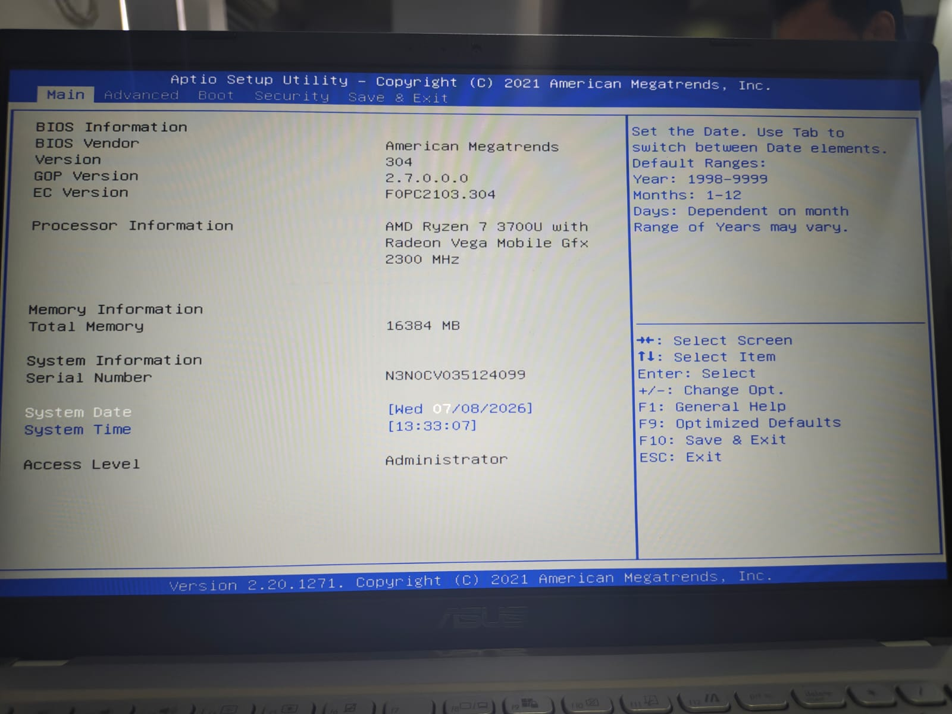

TASK3: Build a LAN Topology in Packet Tracer for 5 Systems and 1 Printer Using a Class C Subnet.
Required devices:
- 1 Switch
- 5 PCs
- 1 Printer
- Ethernet cables
We can use the private Class C network:
192.168.1.0/24
Subnet mask:
255.255.255.0
Device | IP Address | Subnet Mask
PC1 | 192.168.1.1 | 255.255.255.0
PC2 | 192.168.1.2 | 255.255.255.0
PC3 | 192.168.1.3 | 255.255.255.0
PC4 | 192.168.1.4 | 255.255.255.0
PC5 | 192.168.1.5 | 255.255.255.0
Printer | 192.168.1.6 | 255.255.255.0

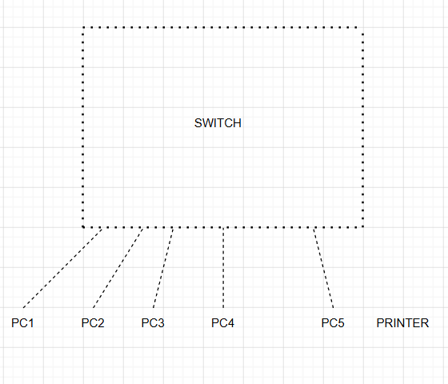

Steps in Packet Tracer:
- Open Cisco Packet Tracer.
- Add one switch.
- Add five PCs.
- Add one printer.
- Connect each device to the switch using Ethernet cables.
- Configure the IP addresses shown above.
- Use the subnet mask:
255.255.255.0
- Use the ping command to test connectivity.

TASK4: Perform a Clean OS Installation with Manual Disk Partitioning and Startup Optimization.
Step 1: Prepare installation media
Create a bootable USB containing the required Windows/Linux ISO.
Step 2: Backup data
Before a clean installation, back up important files because existing partitions may be deleted.
Step 3: Boot from USB
Enter BIOS/UEFI and select the USB as the boot device.
Step 4: Start installation
Select:
- Language
- Time/region
- Keyboard
Then start the installation.
Step 5: Choose clean installation
Select the option for a fresh/custom installation.
Step 6: Manual partitioning
Create the required partitions.
For example:
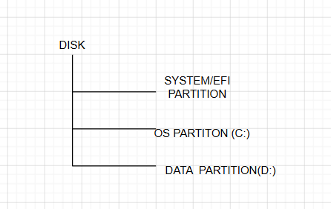

Step 7: Install OS
Select the OS partition and continue installation.
Step 8: Complete setup
Create the user account and configure basic settings.
Step 9: Install drivers
Install required:
- Chipset drivers
- Graphics drivers
- Network drivers
- Audio drivers
Step 10: Update OS
Install available operating-system updates.
Step 11: Startup optimization
Disable unnecessary startup programs.
In Windows:
Task Manager → Startup apps → Disable unnecessary programs
This can improve boot time.
Step 12: Final testing
Check:
- OS boots correctly.
- Keyboard/mouse work.
- Network works.
- Audio works.
- Display works.
- Storage is detected.
The assessment's required final condition is that the OS boots without errors.

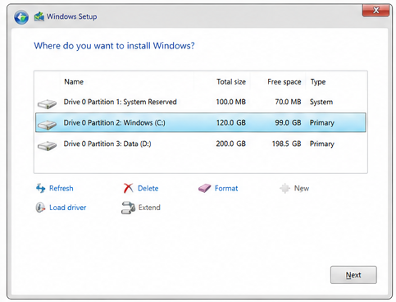

Section C: Integrated Case Study
1.Identify the three hardware components most likely to cause random reboots under load.
The three most likely components are:
I. CPU
During rendering, the CPU can become heavily loaded and generate significant heat.
II. GPU
Rendering can heavily use the GPU, causing high temperature and power consumption.
III.PSU
A PSU that cannot provide stable power under heavy load can cause sudden restarts.

2. Explain why the systems pass POST in the morning but fail in the afternoon.
POST mainly checks whether basic hardware can initialize when the computer starts.
In the morning:
- The computer is relatively cool.
- Workloads are low.
- CPU/GPU temperatures are normal.
- The system successfully completes POST.
In the afternoon:
- Rendering creates a heavy workload.
- CPU and GPU generate more heat.
- Poor ventilation prevents heat from escaping.
- Temperature rises.
- The system may become unstable and restart.

3. How would you use a stress-test tool to confirm a thermal or power issue?
First, monitor the system's temperatures and power behavior at idle.
Then run a controlled stress test.
Procedure:
- Record CPU and GPU temperatures at idle.
- Run a CPU stress test.
- Monitor CPU temperature and system stability.
- Run a GPU stress test.
- Monitor GPU temperature.
- If possible, run a combined CPU + GPU workload.
- Monitor:
  - CPU temperature
  - GPU temperature
  - Fan speed
  - System stability
  - Power behavior
- Stop the test if temperatures become unsafe.
4. Propose three specific steps to remediate the frequent system restarts.
1. Improve ventilation
Remove the workstations from poorly ventilated cabinets and provide sufficient airflow around them.
2. Clean and improve cooling
- Clean dust from fans and heat sinks.
- Check that all fans work correctly.
- Check CPU cooler installation.
- Replace thermal paste if necessary.
3. Check the PSU
Verify that the PSU has:
- Sufficient wattage.
- Appropriate connectors.
- Good quality and stable power output.
If it is inadequate or faulty, replace it with a suitable PSU.
- Provide a brief technical justification for why a PSU upgrade might (or might not) be necessary.
A PSU upgrade may be necessary if the existing PSU:
- Does not provide enough wattage for the CPU and GPU.
- Is old or faulty.
- Cannot provide stable power under heavy load.
- Is of poor quality.
For example, a powerful rendering GPU can significantly increase system power consumption.
However, a PSU upgrade may not be necessary if:
- The PSU has sufficient wattage.
- It is a reliable unit.
- Power remains stable during stress testing.
- The actual problem is overheating.
In this case, because the workstations are specifically described as being in poorly ventilated cabinets, cooling should be investigated first.

